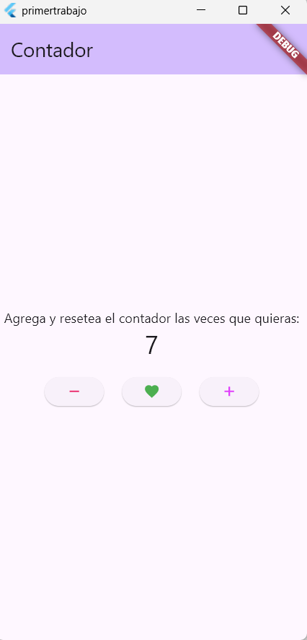
import 'package:flutter/material.dart';

// ejercutar el programa principal
void main() {
runApp(const MyApp());
}

//Clase MyApp
class MyApp extends StatelessWidget {
const MyApp({super.key});

//constructor
@override
Widget build(BuildContext context) {
return MaterialApp( // retorna material App,
title: 'Flutter Demo', //propiedades del widget
theme: ThemeData(
//los comentarios blancos son para verificar donde termina el widget
colorScheme: ColorScheme.fromSeed(seedColor: Colors.deepPurple),
),
home: const MyHomePage(title: 'Contador'),
);
}
}// fin de la clase y del constructor

// clase MyHomePage herada del stateFullWidget
class MyHomePage extends StatefulWidget { // el extend hereda tanto como estado o sin elcon el stateles no es obligatorio utilizar el statefull, pero si utilizo statefull si necesito heredar stateless
const MyHomePage({super.key, required this.title});

// variable final el titulo
final String title;

//creo el estado encapsulandolo despues de heredarlo
@override
State<MyHomePage> createState() => _MyHomePageState();
}
// clase que hereda el estado global
class _MyHomePageState extends State<MyHomePage> {
//varible contadora
int _counter = 0;

//metodo para contar
void _incrementCounter() {
setState(() {
_counter++;
});
}

void _decrementCounter(){
setState(() {
if(_counter <=0){
_counter = 0;
}else{
_counter --;
}
});
}

void _resetCounter(){
setState(() {
_counter = 0;
});
}

//
@override
Widget build(BuildContext context) {
// widget global donde se agrupan todos los widgets

return Scaffold(
appBar: AppBar(
backgroundColor: Theme.of(context).colorScheme.inversePrimary,
title: Text(widget.title),
),
body: Center(
child: Column(
mainAxisAlignment: MainAxisAlignment.center,
children: <Widget>[
const Text('Agrega y resetea el contador las veces que quieras:'),
Text(
'$_counter',
style: Theme.of(context).textTheme.headlineMedium,
),
const SizedBox(height: 20),
Row(
mainAxisAlignment: MainAxisAlignment.center,
children: [
ElevatedButton(
onPressed: _decrementCounter,
child: const Icon(Icons.remove, color: Colors.pink),
),
const SizedBox(width: 20),
ElevatedButton(
onPressed: _resetCounter,
child: const Icon(Icons.favorite, color: Colors.green,),

),
const SizedBox(width: 20),
ElevatedButton(
onPressed: _incrementCounter,
child: const Icon(Icons.add, color: Colors.purpleAccent),
),
],
),
],
),
),

// This trailing comma makes auto-formatting nicer for build methods.
);
}
}

